Air_foil_self_noise:
Model | MAE | RMSE | R2 | FitTime
0 | LinearRegression-Raw | 3.672415 | 4.704109 | 0.558298 | 0.005730
1 | LinearRegression-Processed | 3.672415 | 4.704109 | 0.558298 | 0.001584
2 | RandomForest-Raw | 1.311934 | 1.810725 | 0.934555 | 0.299340
3 | RandomForest-Processed | 1.314014 | 1.814320 | 0.934294 | 0.287080
4 | GradientBoosting-Raw | 2.168912 | 2.860940 | 0.836623 | 0.101869
5 | GradientBoosting-Processed | 2.168912 | 2.860940 | 0.836623 | 0.102522
6 | XGBoost-Raw | 1.012634 | 1.455298 | 0.957725 | 0.087513
7 | XGBoost-Processed | 1.012634 | 1.455298 | 0.957725 | 0.052498
8 | LightGBM-Raw | 1.352272 | 1.922352 | 0.926237 | 0.099767
9 | LightGBM-Processed | 1.352272 | 1.922352 | 0.926237 | 0.058440
10 | Ridge-Raw | 3.946921 | 4.966992 | 0.507551 | 0.006998
11 | Ridge-Processed | 3.673836 | 4.704972 | 0.558136 | 0.001771
12 | SVR-Raw | 5.322520 | 6.803373 | 0.076104 | 0.064722
13 | SVR-Processed | 2.825624 | 3.715104 | 0.724503 | 0.062254
14 | MLP-Raw | 31.890412 | 37.502334 | -27.073153 | 0.355966
15 | MLP-Processed | 3.121401 | 4.004705 | 0.679878 | 5.082208
16 | TabPFN-Raw | 0.648799 | 0.990016 | 0.980436 | 0.318382
17 | TabPFN-Processed | 0.642342 | 0.983060 | 0.980710 | 0.313271
18 | AutoTabPFN-Raw | 0.636452 | 0.996192 | 0.980191 | 108.156211
19 | AutoTabPFN-Processed | 0.643242 | 1.008216 | 0.979710 | 105.362574
20 | AutoGluon-Raw | 0.897007 | 1.417297 | 0.959904 | 152.344050
21 | AutoGluon-Processed | 0.893335 | 1.442772 | 0.958450 | 139.972198

Normalized:
Model | MAE | RMSE | R2 | FitTime
0 | LinearRegression-Raw | 1.089145 | 1.100429 | 0.569279 | 0.005730
1 | LinearRegression-Processed | 1.089145 | 1.100429 | 0.569279 | 0.001584
2 | RandomForest-Raw | 0.389086 | 0.423582 | 0.952937 | 0.299340
3 | RandomForest-Processed | 0.389703 | 0.424423 | 0.952672 | 0.287080
4 | GradientBoosting-Raw | 0.643244 | 0.669258 | 0.853078 | 0.101869
5 | GradientBoosting-Processed | 0.643244 | 0.669258 | 0.853078 | 0.102522
6 | XGBoost-Raw | 0.300322 | 0.340437 | 0.976564 | 0.087513
7 | XGBoost-Processed | 0.300322 | 0.340437 | 0.976564 | 0.052498
8 | LightGBM-Raw | 0.401050 | 0.449695 | 0.944455 | 0.099767
9 | LightGBM-Processed | 0.401050 | 0.449695 | 0.944455 | 0.058440
10 | Ridge-Raw | 1.170557 | 1.161925 | 0.517534 | 0.006998
11 | Ridge-Processed | 1.089567 | 1.100631 | 0.569114 | 0.001771
12 | SVR-Raw | 1.578525 | 1.591509 | 0.077601 | 0.064722
13 | SVR-Processed | 0.838008 | 0.869072 | 0.738754 | 0.062254
14 | MLP-Raw | 9.457889 | 8.772897 | -27.605669 | 0.355966
15 | MLP-Processed | 0.925729 | 0.936818 | 0.693251 | 5.082208
16 | TabPFN-Raw | 0.192417 | 0.231594 | 0.999721 | 0.318382
17 | TabPFN-Processed | 0.190502 | 0.229967 | 1.000000 | 0.313271
18 | AutoTabPFN-Raw | 0.188755 | 0.233039 | 0.999471 | 108.156211
19 | AutoTabPFN-Processed | 0.190769 | 0.235851 | 0.998980 | 105.362574
20 | AutoGluon-Raw | 0.266029 | 0.331547 | 0.978785 | 152.344050
21 | AutoGluon-Processed | 0.264940 | 0.337507 | 0.977302 | 139.972198
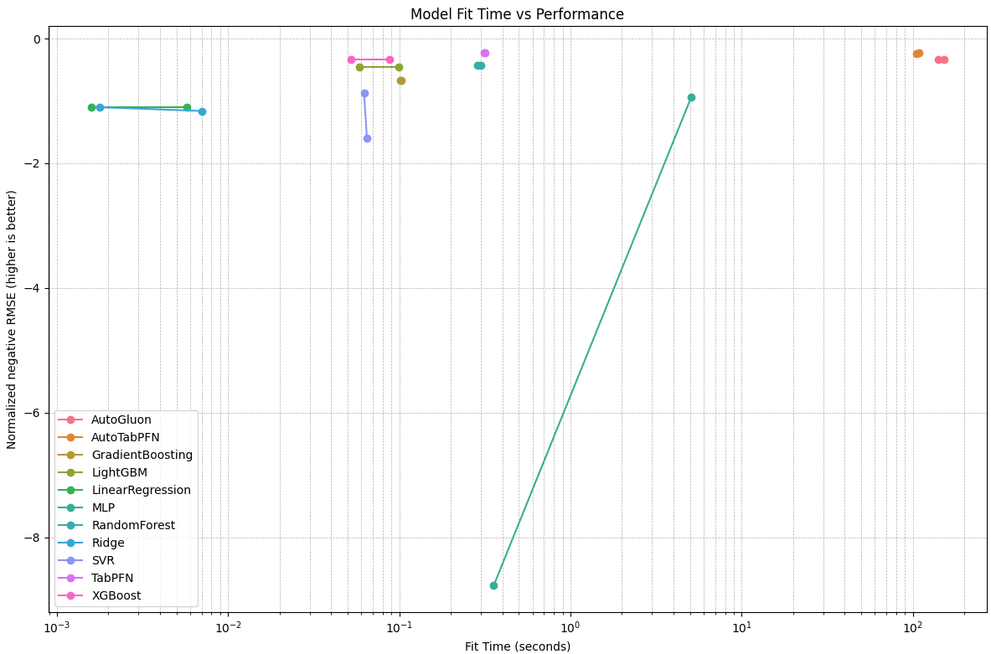

Plots:
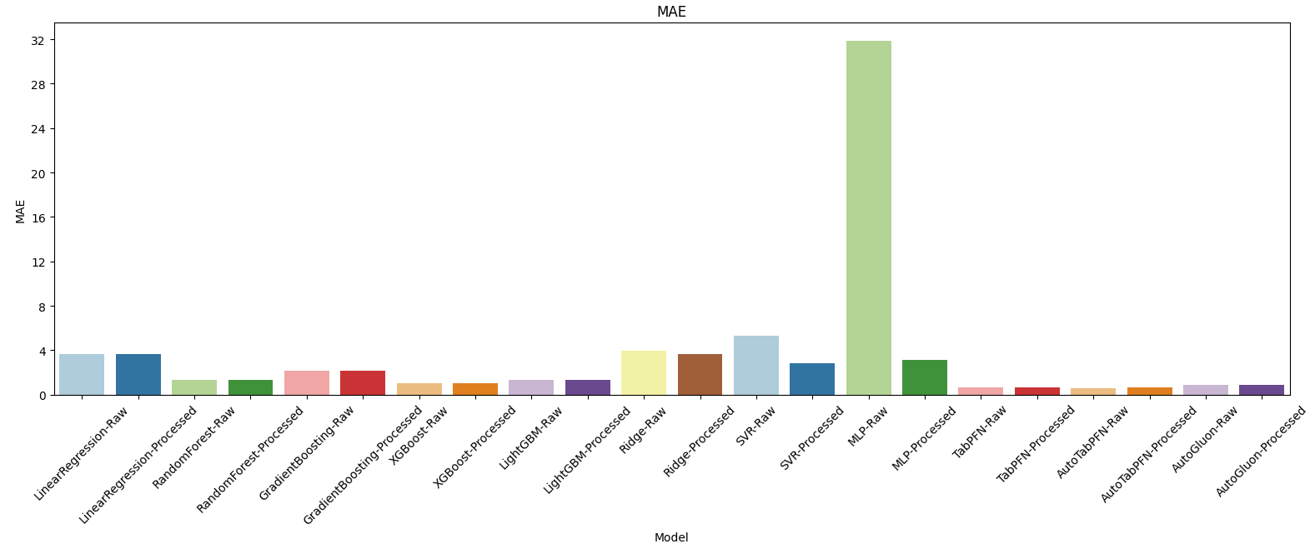
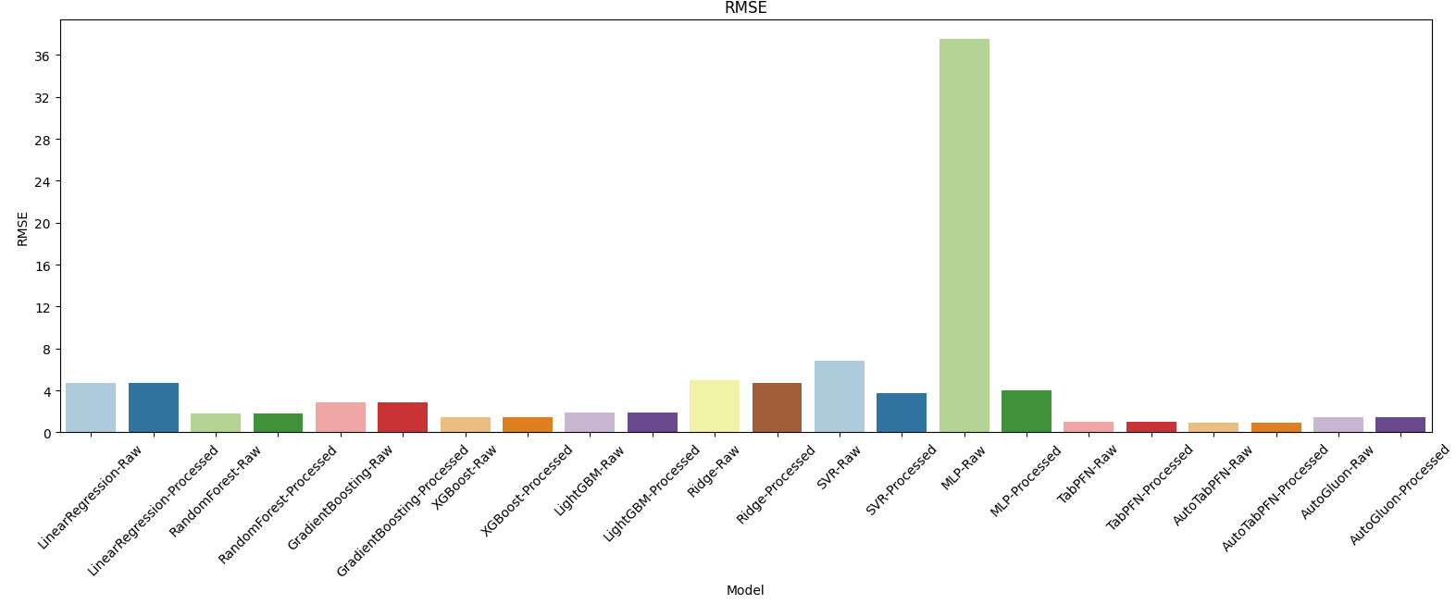
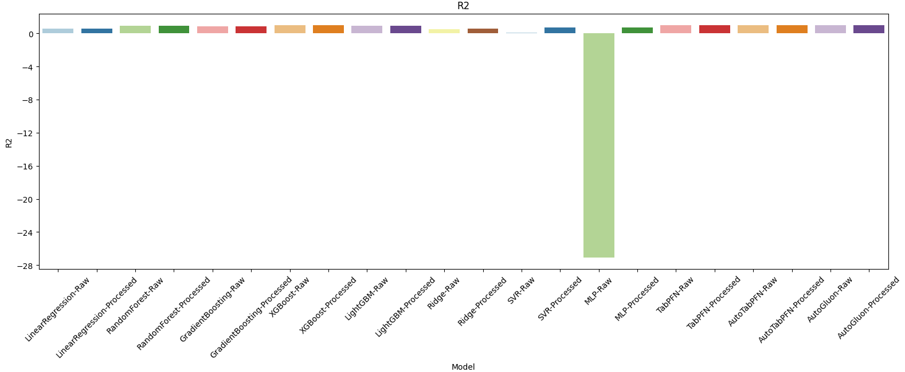
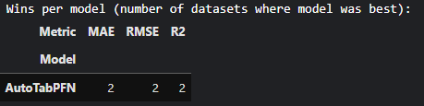
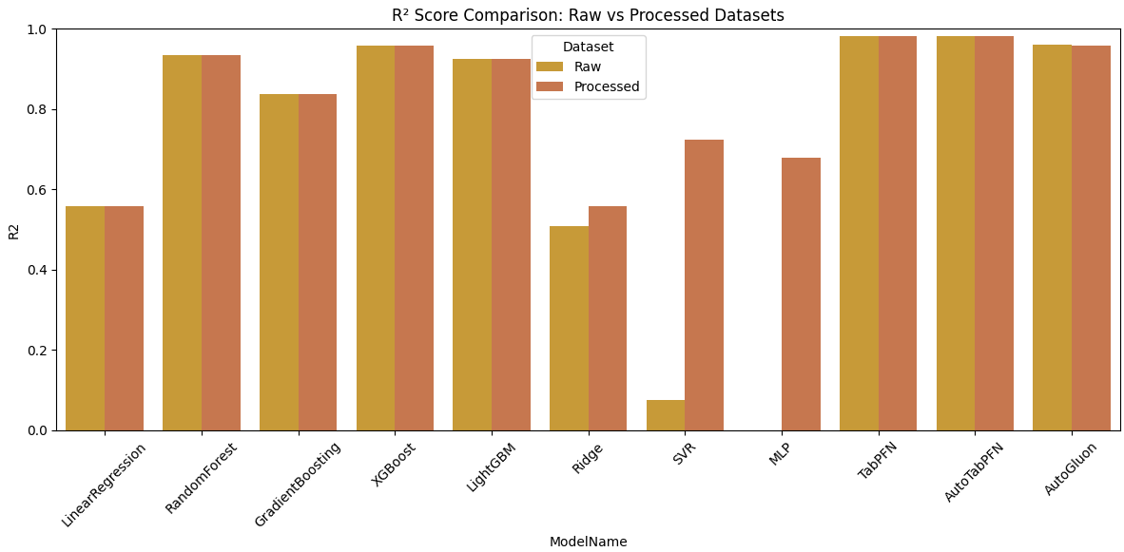
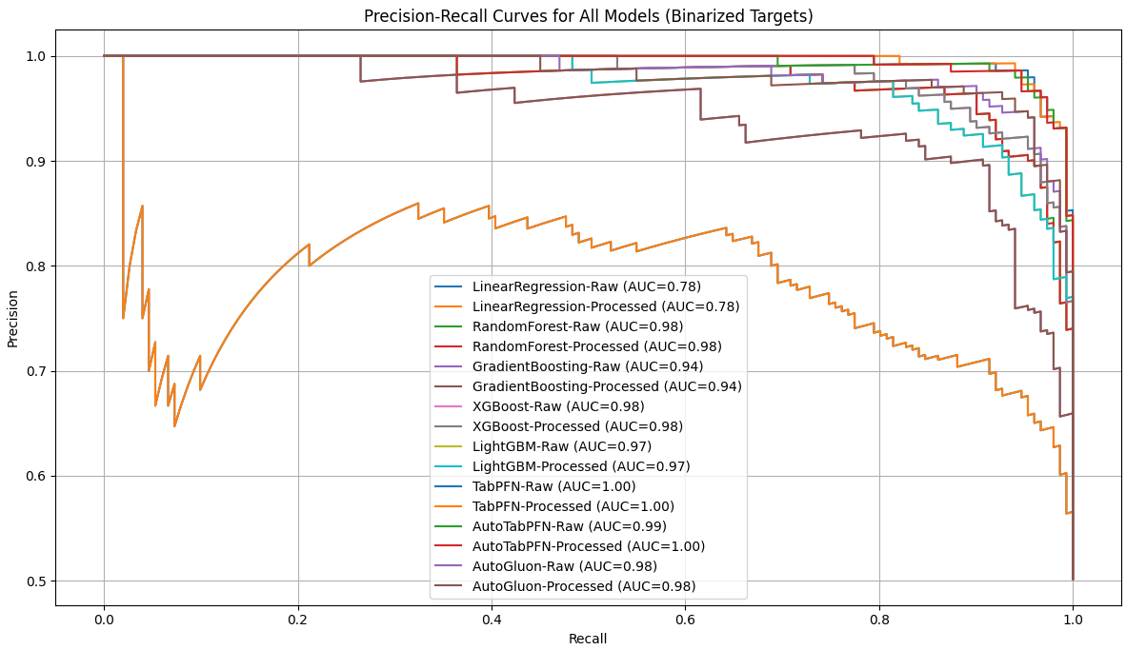

Auction Verification Dataset:
Model | MAE | RMSE | R2 | FitTime
0 | LinearRegression-Raw | 6160.995924 | 8019.172945 | 0.383359 | 0.007113
1 | LinearRegression-Processed | 6160.995924 | 8019.172945 | 0.383359 | 0.002464
2 | RandomForest-Raw | 365.269064 | 798.983573 | 0.993879 | 0.355489
3 | RandomForest-Processed | 361.014970 | 798.192271 | 0.993891 | 0.350075
4 | GradientBoosting-Raw | 985.069708 | 1520.104962 | 0.977843 | 0.115813
5 | GradientBoosting-Processed | 985.069708 | 1520.104962 | 0.977843 | 0.117005
6 | XGBoost-Raw | 171.978850 | 346.294520 | 0.998850 | 0.079999
7 | XGBoost-Processed | 171.978850 | 346.294520 | 0.998850 | 0.053022
8 | LightGBM-Raw | 429.847541 | 769.056003 | 0.994329 | 0.095142
9 | LightGBM-Processed | 429.847541 | 769.056003 | 0.994329 | 0.055957
10 | Ridge-Raw | 6159.194192 | 8018.624843 | 0.383443 | 0.005331
11 | Ridge-Processed | 6159.540175 | 8018.855116 | 0.383408 | 0.001722
12 | SVR-Raw | 6633.229514 | 11800.887210 | -0.335373 | 0.127623
13 | SVR-Processed | 6583.678484 | 11761.372060 | -0.326445 | 0.126754
14 | MLP-Raw | 6097.515903 | 8424.323182 | 0.319476 | 5.668720
15 | MLP-Processed | 5204.080721 | 7521.388542 | 0.457538 | 6.136423
16 | TabPFN-Raw | 427.872442 | 968.018117 | 0.991015 | 0.459139
17 | TabPFN-Processed | 403.854230 | 910.027567 | 0.992059 | 0.354839
18 | AutoTabPFN-Raw | 343.783747 | 748.992159 | 0.994621 | 172.178159
19 | AutoTabPFN-Processed | 461.630491 | 804.940143 | 0.993787 | 149.578139
20 | AutoGluon-Raw | 151.439726 | 314.978589 | 0.999049 | 120.373065
21 | AutoGluon-Processed | 152.109237 | 314.736896 | 0.999050 | 119.419220

Normalized:
Model | MAE | RMSE | R2 | FitTime
0 | LinearRegression-Raw | 2.464399 | 2.138094 | 0.383724 | 0.007113
1 | LinearRegression-Processed | 2.464399 | 2.138094 | 0.383724 | 0.002464
2 | RandomForest-Raw | 0.146108 | 0.213027 | 0.994824 | 0.355489
3 | RandomForest-Processed | 0.144406 | 0.212816 | 0.994836 | 0.350075
4 | GradientBoosting-Raw | 0.394028 | 0.405295 | 0.978772 | 0.115813
5 | GradientBoosting-Processed | 0.394028 | 0.405295 | 0.978772 | 0.117005
6 | XGBoost-Raw | 0.068792 | 0.092330 | 0.999800 | 0.079999
7 | XGBoost-Processed | 0.068792 | 0.092330 | 0.999800 | 0.053022
8 | LightGBM-Raw | 0.171939 | 0.205048 | 0.995274 | 0.095142
9 | LightGBM-Processed | 0.171939 | 0.205048 | 0.995274 | 0.055957
10 | Ridge-Raw | 2.463678 | 2.137948 | 0.383808 | 0.005331
11 | Ridge-Processed | 2.463816 | 2.138010 | 0.383773 | 0.001722
12 | SVR-Raw | 2.653292 | 3.146385 | -0.335691 | 0.127623
13 | SVR-Processed | 2.633472 | 3.135850 | -0.326755 | 0.126754
14 | MLP-Raw | 2.439006 | 2.246117 | 0.319780 | 5.668720
15 | MLP-Processed | 2.081632 | 2.005374 | 0.457973 | 6.136423
16 | TabPFN-Raw | 0.171149 | 0.258096 | 0.991957 | 0.459139
17 | TabPFN-Processed | 0.161542 | 0.242634 | 0.993002 | 0.354839
18 | AutoTabPFN-Raw | 0.137514 | 0.199698 | 0.995566 | 172.178159
19 | AutoTabPFN-Processed | 0.184652 | 0.214615 | 0.994732 | 149.578139
20 | AutoGluon-Raw | 0.060576 | 0.083980 | 0.999999 | 120.373065
21 | AutoGluon-Processed | 0.060844 | 0.083916 | 1.000000 | 119.419220

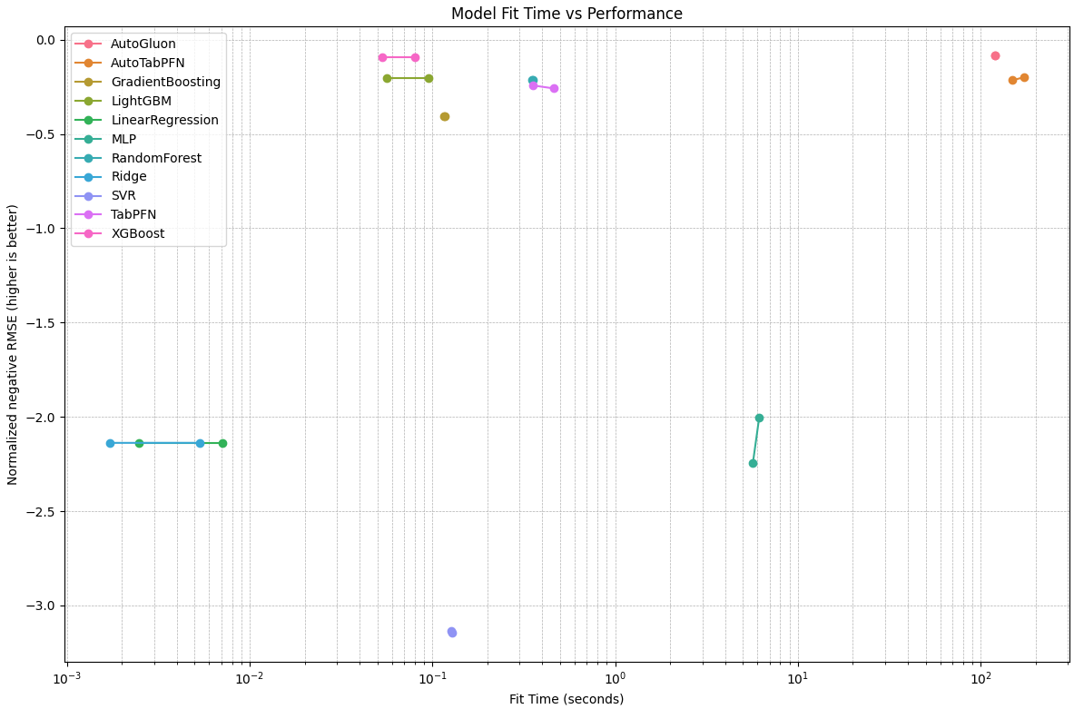
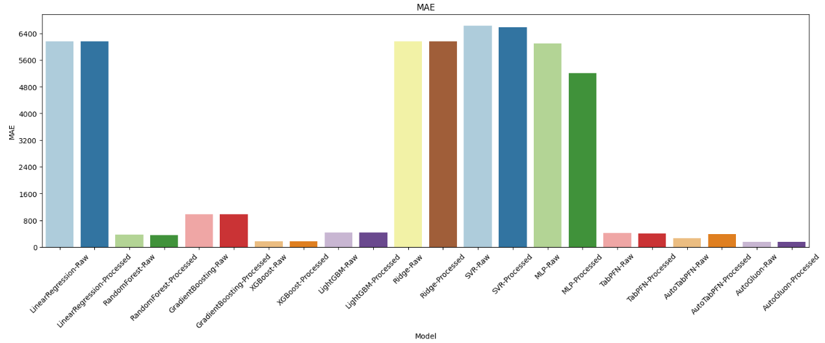
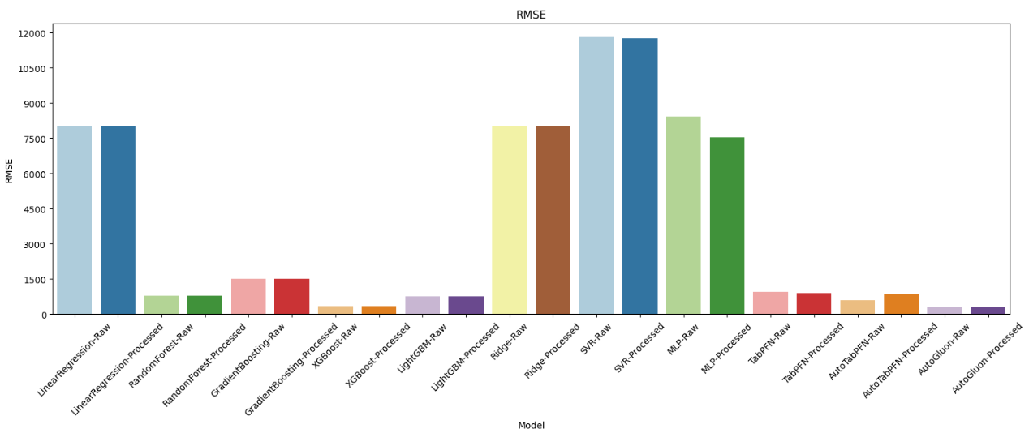
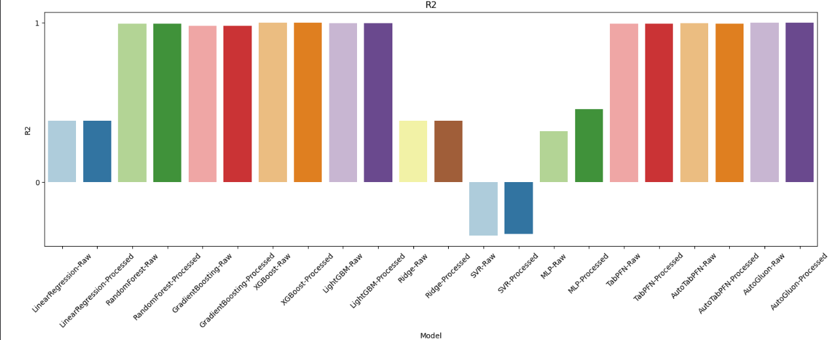
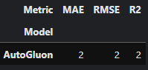
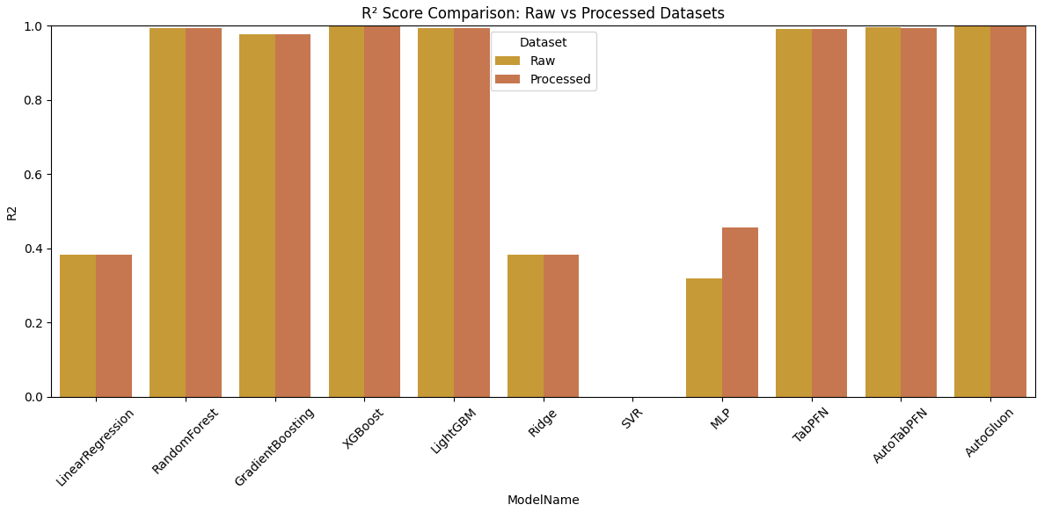
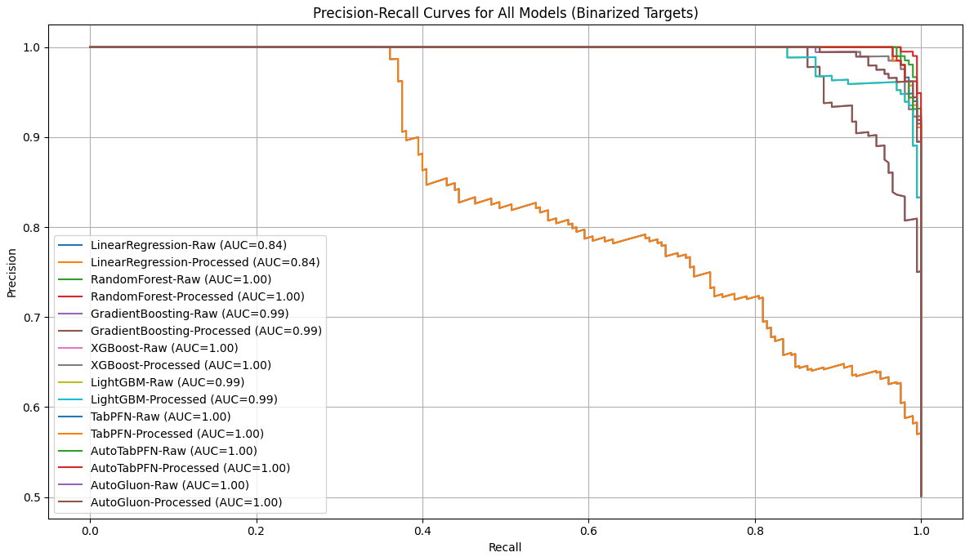

Boston:
Model | MAE | RMSE | R2 | FitTime
0 | LinearRegression-Raw | 64277.288657 | 82395.543322 | 0.691093 | 0.004161
1 | LinearRegression-Processed | 64277.288657 | 82395.543322 | 0.691093 | 0.001337
2 | RandomForest-Raw | 43862.785714 | 56966.388630 | 0.852342 | 0.191645
3 | RandomForest-Processed | 43799.571429 | 57056.802197 | 0.851873 | 0.164448
4 | GradientBoosting-Raw | 44874.620867 | 57963.605727 | 0.847127 | 0.079723
5 | GradientBoosting-Processed | 45148.409398 | 58129.924789 | 0.846249 | 0.078570
6 | XGBoost-Raw | 50061.517060 | 64413.583438 | 0.811212 | 0.083390
7 | XGBoost-Processed | 50061.517060 | 64413.583438 | 0.811212 | 0.047671
8 | LightGBM-Raw | 48836.238857 | 61007.029936 | 0.830652 | 0.063745
9 | LightGBM-Processed | 49806.098180 | 61745.299920 | 0.826529 | 0.027359
10 | Ridge-Raw | 64290.755723 | 82387.982730 | 0.691150 | 0.008643
11 | Ridge-Processed | 64274.423031 | 82413.117460 | 0.690962 | 0.001473
12 | SVR-Raw | 109075.561326 | 149608.357609 | -0.018431 | 0.007288
13 | SVR-Processed | 109087.081915 | 149622.050238 | -0.018617 | 0.006852
14 | MLP-Raw | 402801.042169 | 430353.122994 | -7.426935 | 1.165692
15 | MLP-Processed | 423907.036144 | 448951.708193 | -8.171049 | 1.362759
16 | TabPFN-Raw | 44494.491231 | 57574.290211 | 0.849174 | 0.282521
17 | TabPFN-Processed | 44360.518176 | 57574.056743 | 0.849175 | 0.268714
18 | AutoTabPFN-Raw | 44243.631537 | 57445.317120 | 0.849849 | 105.140757
19 | AutoTabPFN-Processed | 45235.387436 | 58602.819623 | 0.843737 | 101.490031
20 | AutoGluon-Raw | 44939.983578 | 58209.298069 | 0.845828 | 10.905599
21 | AutoGluon-Processed | 44928.227997 | 58211.997330 | 0.845814 | 9.949822

Normalized:
Model | MAE | RMSE | R2 | FitTime
0 | LinearRegression-Raw | 0.726430 | 0.775507 | 0.810817 | 0.004161
1 | LinearRegression-Processed | 0.726430 | 0.775507 | 0.810817 | 0.001337
2 | RandomForest-Raw | 0.495715 | 0.536168 | 1.000000 | 0.191645
3 | RandomForest-Processed | 0.495001 | 0.537019 | 0.999450 | 0.164448
4 | GradientBoosting-Raw | 0.507151 | 0.545553 | 0.993882 | 0.079723
5 | GradientBoosting-Processed | 0.510245 | 0.547119 | 0.992851 | 0.078570
6 | XGBoost-Raw | 0.565770 | 0.606261 | 0.951745 | 0.083390
7 | XGBoost-Processed | 0.565770 | 0.606261 | 0.951745 | 0.047671
8 | LightGBM-Raw | 0.551923 | 0.574198 | 0.974553 | 0.063745
9 | LightGBM-Processed | 0.562884 | 0.581147 | 0.969715 | 0.027359
10 | Ridge-Raw | 0.726582 | 0.775436 | 0.810884 | 0.008643
11 | Ridge-Processed | 0.726398 | 0.775672 | 0.810662 | 0.001473
12 | SVR-Raw | 1.232718 | 1.408114 | -0.021624 | 0.007288
13 | SVR-Processed | 1.232848 | 1.408243 | -0.021842 | 0.006852
14 | MLP-Raw | 4.552258 | 4.050484 | -8.713563 | 1.165692
15 | MLP-Processed | 4.790787 | 4.225534 | -9.586585 | 1.362759
16 | TabPFN-Raw | 0.502855 | 0.541889 | 0.996283 | 0.282521
17 | TabPFN-Processed | 0.501341 | 0.541887 | 0.996284 | 0.268714
18 | AutoTabPFN-Raw | 0.500020 | 0.540675 | 0.997075 | 105.140757
19 | AutoTabPFN-Processed | 0.511228 | 0.551570 | 0.989904 | 101.490031
20 | AutoGluon-Raw | 0.507889 | 0.547866 | 0.992358 | 10.905599
21 | AutoGluon-Processed | 0.507757 | 0.547891 | 0.992341 | 9.949822
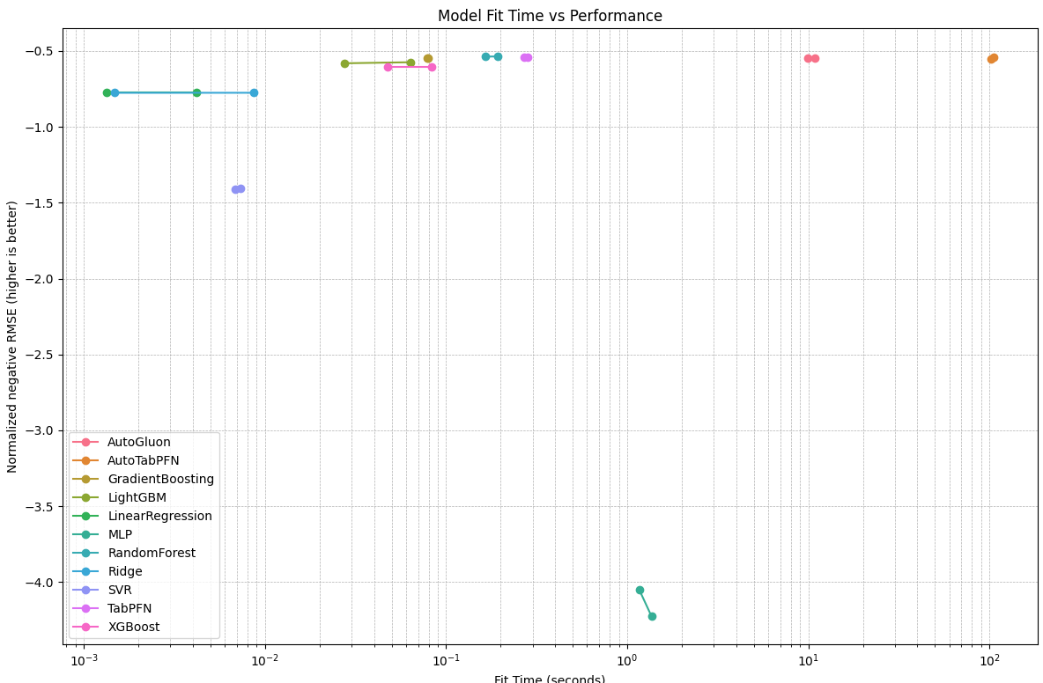
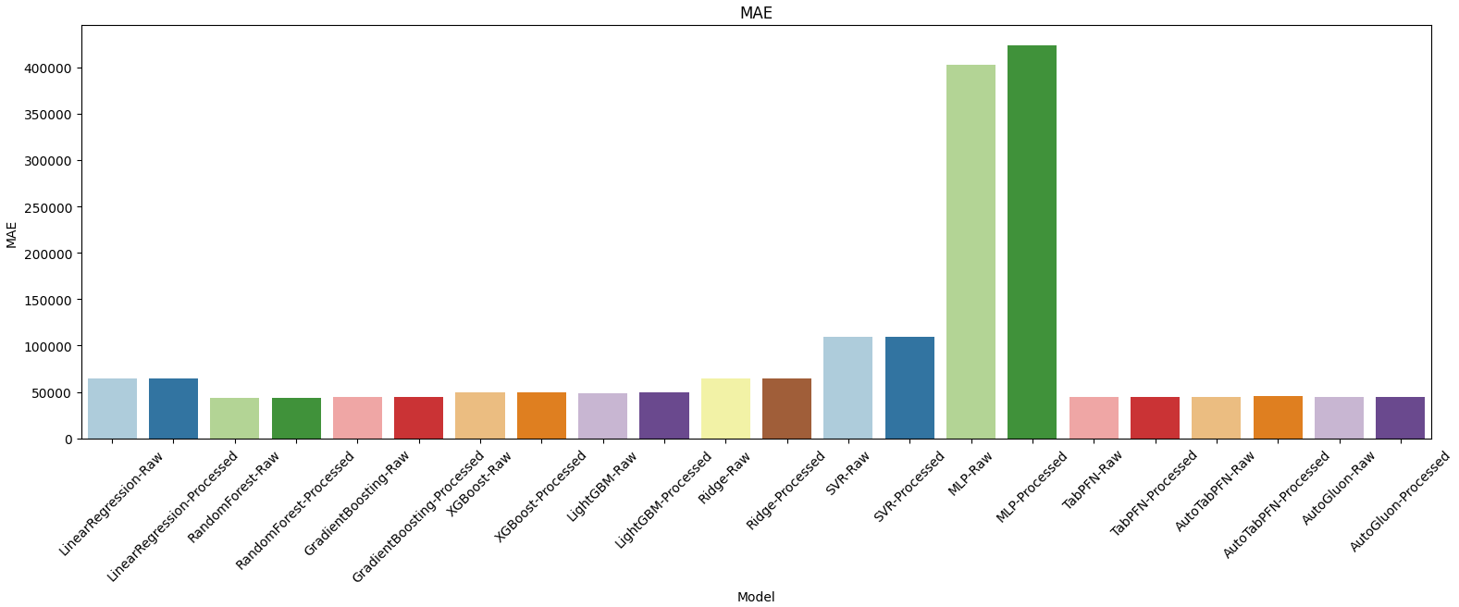
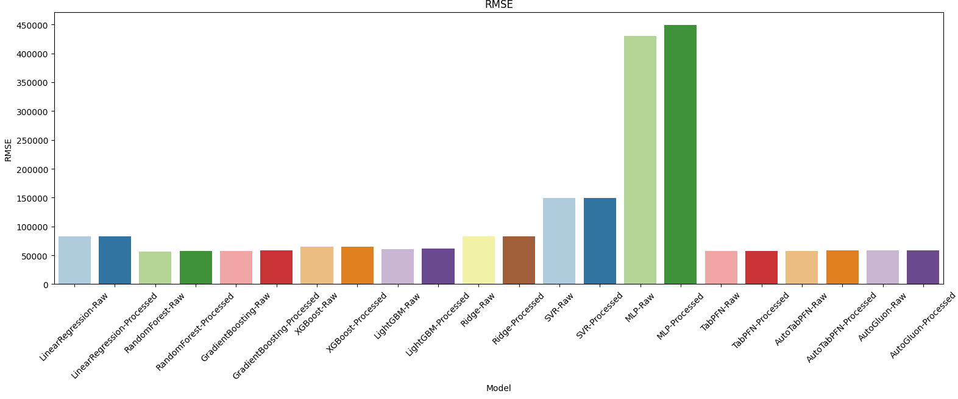
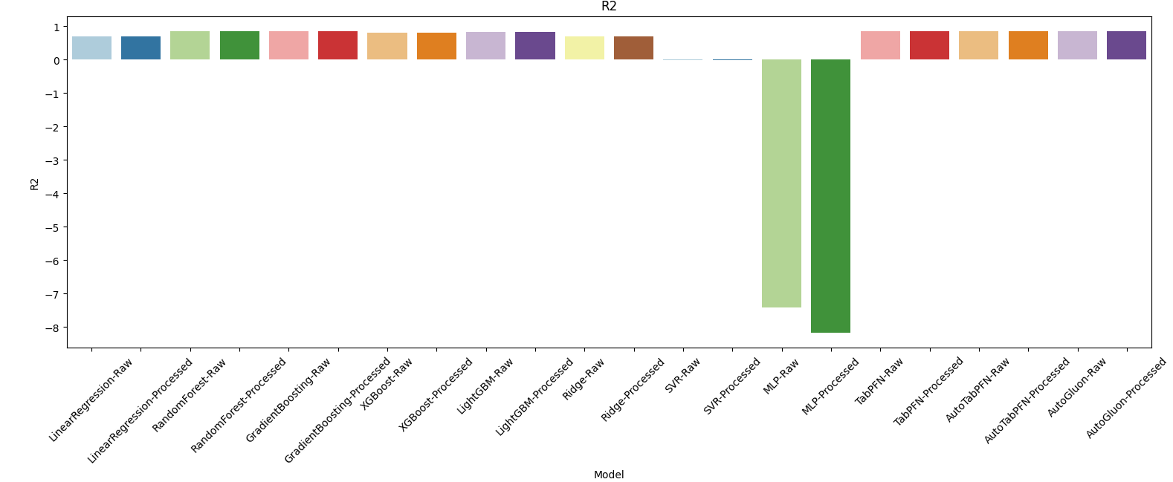
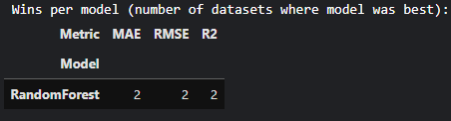
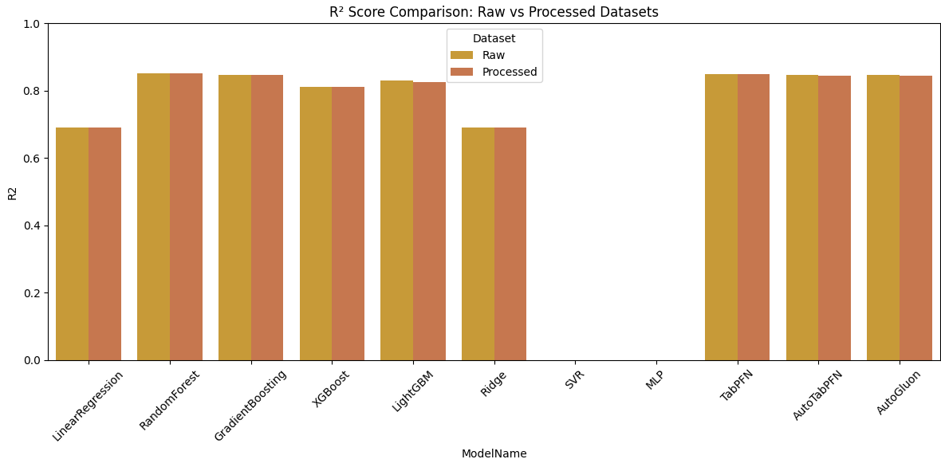
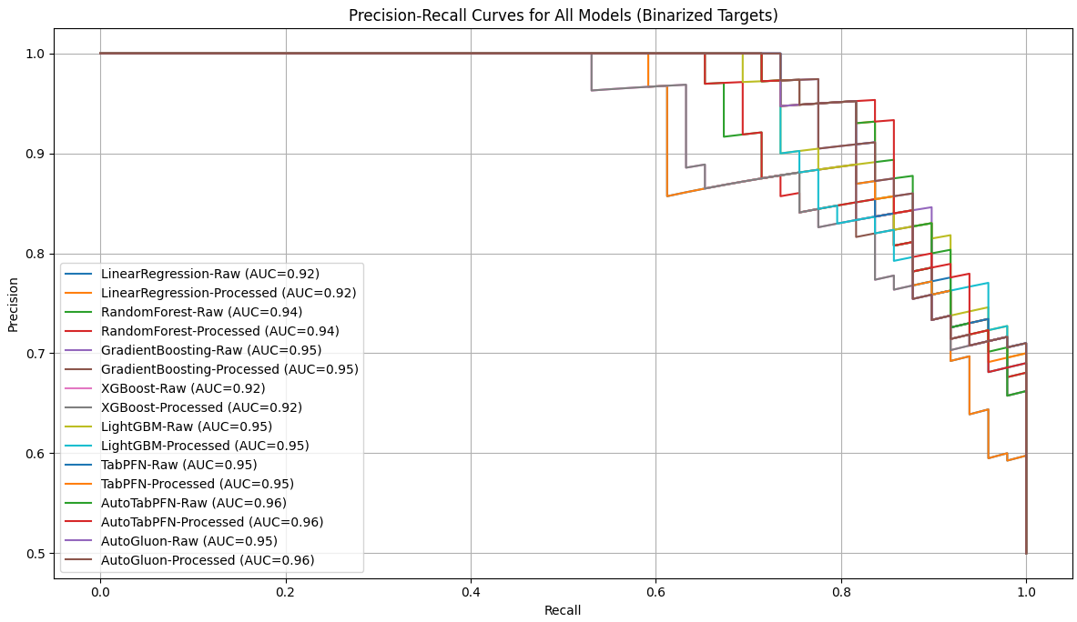

College dataset:
Model | MAE | RMSE | R2 | FitTime
0 | LinearRegression-Raw | 586.053079 | 760.981419 | 0.446177 | 0.008872
1 | LinearRegression-Processed | 586.053079 | 760.981419 | 0.446177 | 0.002065
2 | RandomForest-Raw | 534.949359 | 686.928861 | 0.548719 | 0.726305
3 | RandomForest-Processed | 535.380128 | 687.180515 | 0.548389 | 0.685153
4 | GradientBoosting-Raw | 543.377467 | 689.563576 | 0.545251 | 0.279053
5 | GradientBoosting-Processed | 544.747694 | 690.663404 | 0.543799 | 0.287912
6 | XGBoost-Raw | 524.239516 | 705.995376 | 0.523320 | 0.208000
7 | XGBoost-Processed | 524.239516 | 705.995376 | 0.523320 | 0.143673
8 | LightGBM-Raw | 536.620298 | 689.534380 | 0.545289 | 0.114964
9 | LightGBM-Processed | 540.978071 | 706.024141 | 0.523281 | 0.063222
10 | Ridge-Raw | 585.727290 | 760.838850 | 0.446384 | 0.007466
11 | Ridge-Processed | 585.578118 | 760.513499 | 0.446857 | 0.001880
12 | SVR-Raw | 805.502839 | 1024.912585 | -0.004609 | 0.021161
13 | SVR-Processed | 808.985933 | 1031.046295 | -0.016669 | 0.019117
14 | MLP-Raw | 660.340538 | 847.061806 | 0.313796 | 1.187848
15 | MLP-Processed | 1210.492280 | 1580.106966 | -1.387791 | 2.528059
16 | TabPFN-Raw | 495.296063 | 649.378653 | 0.596708 | 0.432762
17 | TabPFN-Processed | 497.611093 | 652.829851 | 0.592410 | 0.418419
18 | AutoTabPFN-Raw | 489.589260 | 650.132593 | 0.595771 | 137.070709
19 | AutoTabPFN-Processed | 493.846861 | 648.687102 | 0.597567 | 129.713706
20 | AutoGluon-Raw | 542.091338 | 686.468362 | 0.549324 | 8.617138
21 | AutoGluon-Processed | 542.162560 | 686.974584 | 0.548659 | 7.727664

Normalized:
Model | MAE | RMSE | R2 | FitTime
0 | LinearRegression-Raw | 0.978693 | 0.981175 | 0.746655 | 0.008872
1 | LinearRegression-Processed | 0.978693 | 0.981175 | 0.746655 | 0.002065
2 | RandomForest-Raw | 0.893351 | 0.885695 | 0.918256 | 0.726305
3 | RandomForest-Processed | 0.894071 | 0.886019 | 0.917702 | 0.685153
4 | GradientBoosting-Raw | 0.907426 | 0.889092 | 0.912452 | 0.279053
5 | GradientBoosting-Processed | 0.909714 | 0.890510 | 0.910022 | 0.287912
6 | XGBoost-Raw | 0.875466 | 0.910278 | 0.875751 | 0.208000
7 | XGBoost-Processed | 0.875466 | 0.910278 | 0.875751 | 0.143673
8 | LightGBM-Raw | 0.896142 | 0.889054 | 0.912516 | 0.114964
9 | LightGBM-Processed | 0.903419 | 0.910316 | 0.875686 | 0.063222
10 | Ridge-Raw | 0.978149 | 0.980991 | 0.747003 | 0.007466
11 | Ridge-Processed | 0.977900 | 0.980572 | 0.747795 | 0.001880
12 | SVR-Raw | 1.345168 | 1.321476 | -0.007712 | 0.021161
13 | SVR-Processed | 1.350985 | 1.329384 | -0.027895 | 0.019117
14 | MLP-Raw | 1.102751 | 1.092163 | 0.525122 | 1.187848
15 | MLP-Processed | 2.021490 | 2.037318 | -2.322402 | 2.528059
16 | TabPFN-Raw | 0.827131 | 0.837279 | 0.998563 | 0.432762
17 | TabPFN-Processed | 0.830997 | 0.841729 | 0.991371 | 0.418419
18 | AutoTabPFN-Raw | 0.817601 | 0.838251 | 0.996995 | 137.070709
19 | AutoTabPFN-Processed | 0.824711 | 0.836388 | 1.000000 | 129.713706
20 | AutoGluon-Raw | 0.905278 | 0.885101 | 0.919268 | 8.617138
21 | AutoGluon-Processed | 0.905397 | 0.885754 | 0.918155 | 7.727664
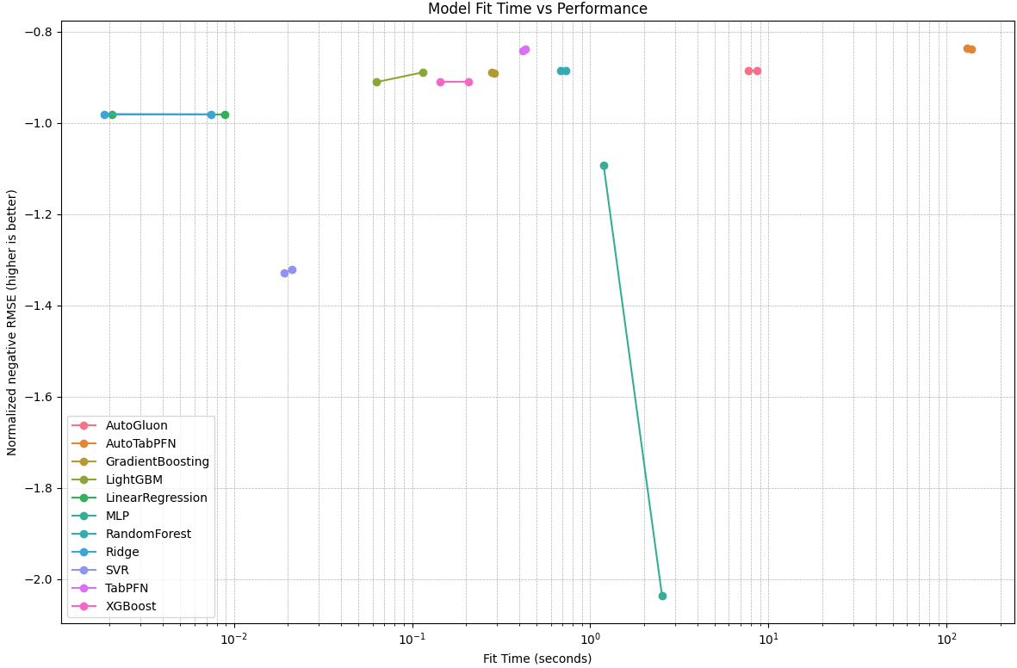
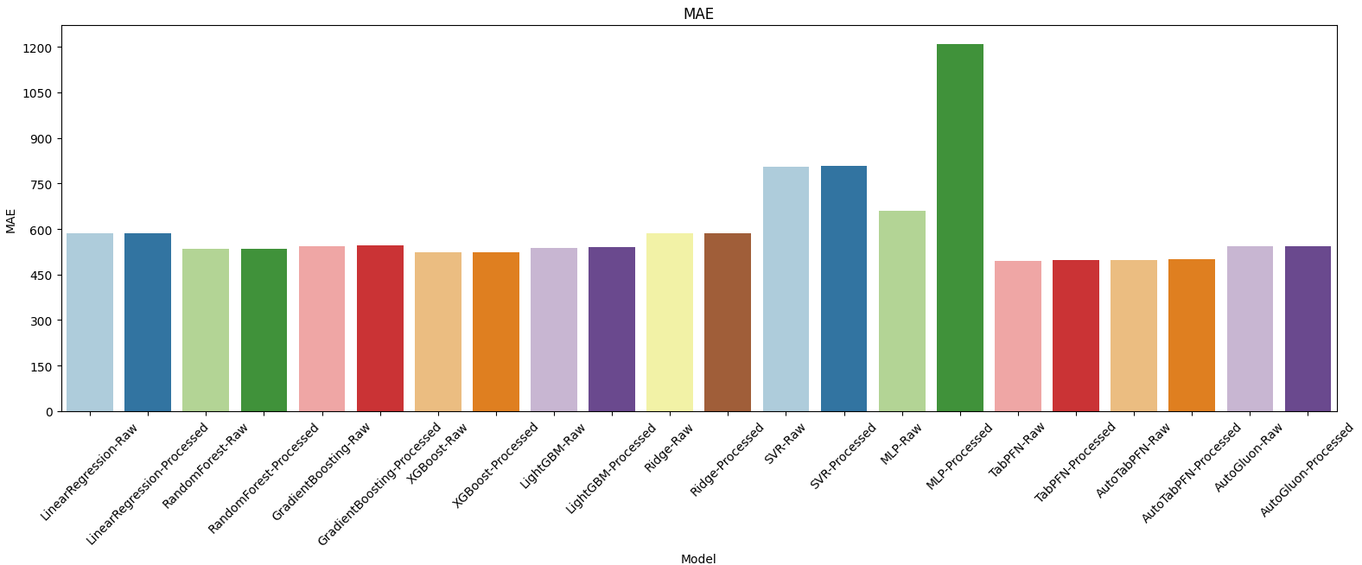
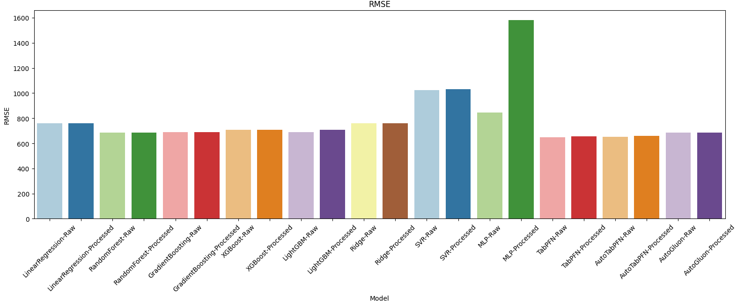
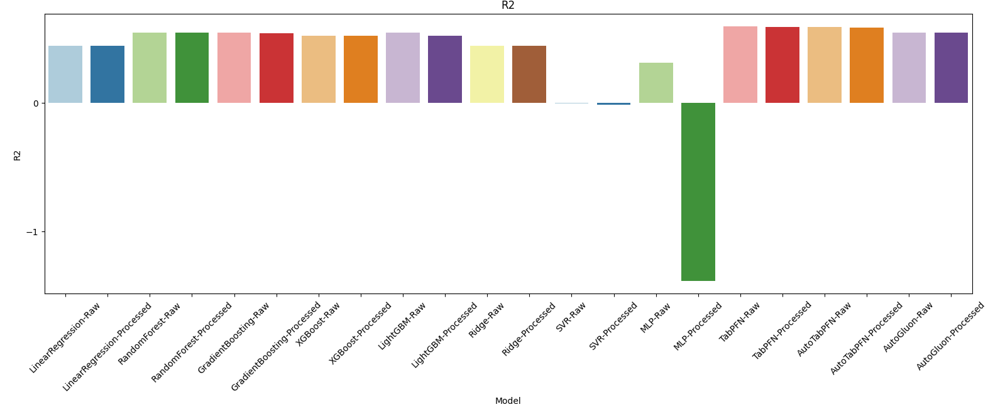
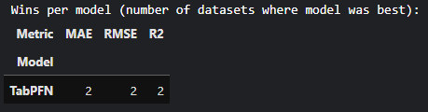
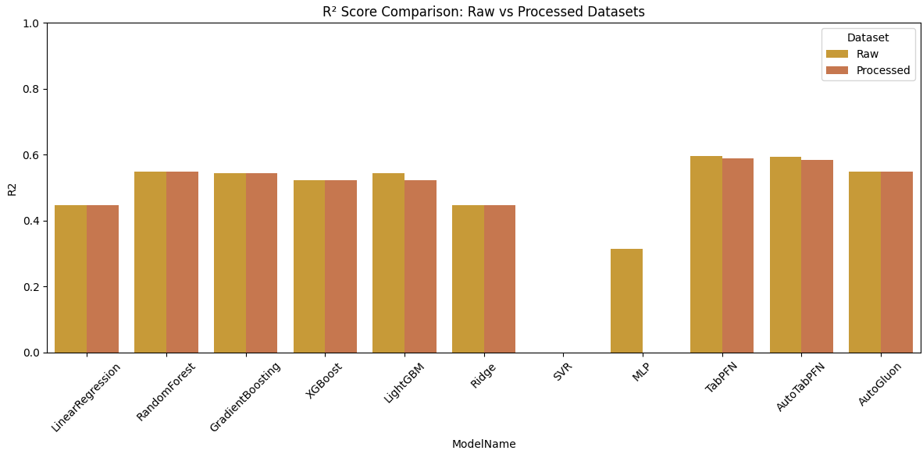
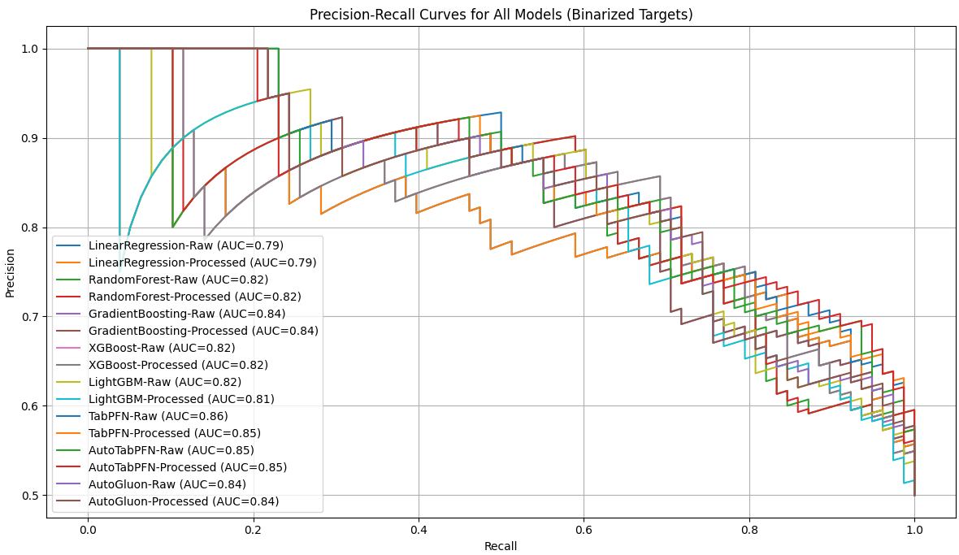

concrete-compressive-strength-data-set:
Model | MAE | RMSE | R2 | FitTime
0 | LinearRegression-Raw | 7.745559 | 9.796476 | 0.627553 | 0.006567
1 | LinearRegression-Processed | 7.745559 | 9.796476 | 0.627553 | 0.001439
2 | RandomForest-Raw | 3.737467 | 5.458506 | 0.884370 | 0.378084
3 | RandomForest-Processed | 3.740348 | 5.466529 | 0.884029 | 0.402993
4 | GradientBoosting-Raw | 4.135014 | 5.493350 | 0.882889 | 0.152461
5 | GradientBoosting-Processed | 4.135014 | 5.493350 | 0.882889 | 0.150776
6 | XGBoost-Raw | 2.996375 | 4.606305 | 0.917656 | 0.142211
7 | XGBoost-Processed | 2.996375 | 4.606305 | 0.917656 | 0.082938
8 | LightGBM-Raw | 3.163961 | 4.690180 | 0.914630 | 0.152368
9 | LightGBM-Processed | 3.200504 | 4.706550 | 0.914033 | 0.062487
10 | Ridge-Raw | 7.745554 | 9.796474 | 0.627553 | 0.008871
11 | Ridge-Processed | 7.751887 | 9.796097 | 0.627582 | 0.001504
12 | SVR-Raw | 11.507302 | 14.067736 | 0.231979 | 0.028573
13 | SVR-Processed | 7.567223 | 9.524278 | 0.647963 | 0.029287
14 | MLP-Raw | 7.038184 | 9.144224 | 0.675497 | 0.362906
15 | MLP-Processed | 4.400782 | 5.768178 | 0.870878 | 3.458643
16 | TabPFN-Raw | 2.557091 | 4.347280 | 0.926657 | 0.380535
17 | TabPFN-Processed | 2.585152 | 4.419113 | 0.924213 | 0.354850
18 | AutoTabPFN-Raw | 2.568828 | 4.652379 | 0.916001 | 269.338356
19 | AutoTabPFN-Processed | 2.475901 | 4.305895 | 0.928047 | 258.490973
20 | AutoGluon-Raw | 2.914799 | 4.519101 | 0.920745 | 33.721749
21 | AutoGluon-Processed | 2.863288 | 4.439916 | 0.923498 | 32.785874

Normalized:
Model | MAE | RMSE | R2 | FitTime
0 | LinearRegression-Raw | 1.614084 | 1.487442 | 0.676209 | 0.006567
1 | LinearRegression-Processed | 1.614084 | 1.487442 | 0.676209 | 0.001439
2 | RandomForest-Raw | 0.778844 | 0.828789 | 0.952937 | 0.378084
3 | RandomForest-Processed | 0.779445 | 0.830007 | 0.952570 | 0.402993
4 | GradientBoosting-Raw | 0.861688 | 0.834080 | 0.951341 | 0.152461
5 | GradientBoosting-Processed | 0.861688 | 0.834080 | 0.951341 | 0.150776
6 | XGBoost-Raw | 0.624409 | 0.699396 | 0.988804 | 0.142211
7 | XGBoost-Processed | 0.624409 | 0.699396 | 0.988804 | 0.082938
8 | LightGBM-Raw | 0.659332 | 0.712131 | 0.985544 | 0.152368
9 | LightGBM-Processed | 0.666947 | 0.714616 | 0.984900 | 0.062487
10 | Ridge-Raw | 1.614082 | 1.487442 | 0.676209 | 0.008871
11 | Ridge-Processed | 1.615402 | 1.487384 | 0.676240 | 0.001504
12 | SVR-Raw | 2.397986 | 2.135966 | 0.249965 | 0.028573
13 | SVR-Processed | 1.576920 | 1.446113 | 0.698201 | 0.029287
14 | MLP-Raw | 1.466675 | 1.388408 | 0.727870 | 0.362906
15 | MLP-Processed | 0.917071 | 0.875808 | 0.938399 | 3.458643
16 | TabPFN-Raw | 0.532868 | 0.660067 | 0.998503 | 0.380535
17 | TabPFN-Processed | 0.538715 | 0.670973 | 0.995869 | 0.354850
18 | AutoTabPFN-Raw | 0.535314 | 0.706391 | 0.987020 | 269.338356
19 | AutoTabPFN-Processed | 0.515949 | 0.653783 | 1.000000 | 258.490973
20 | AutoGluon-Raw | 0.607410 | 0.686155 | 0.992132 | 33.721749
21 | AutoGluon-Processed | 0.596676 | 0.674132 | 0.995099 | 32.785874
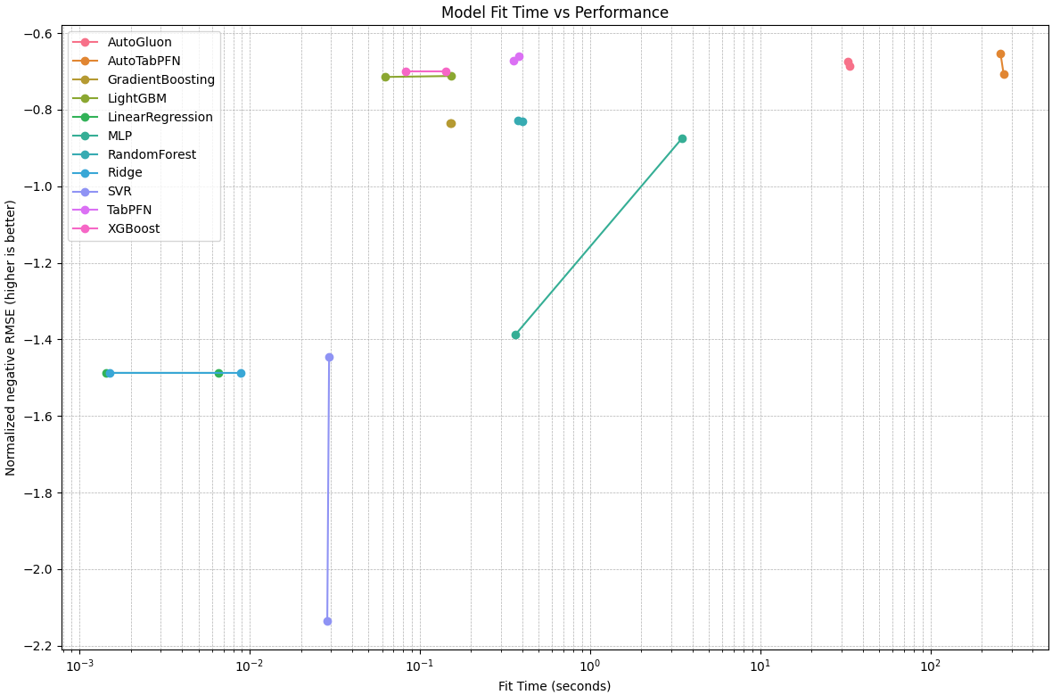
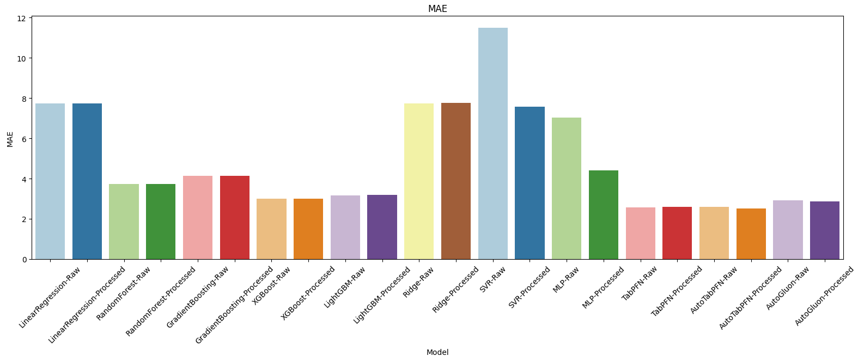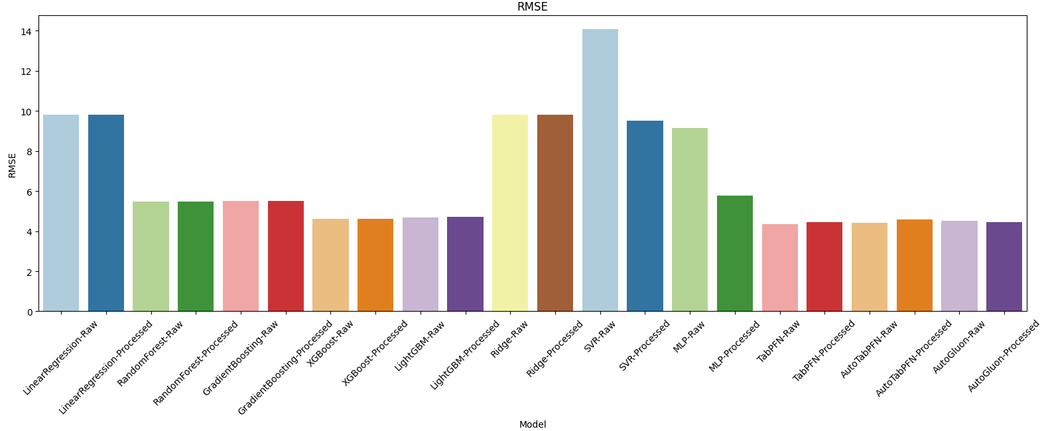
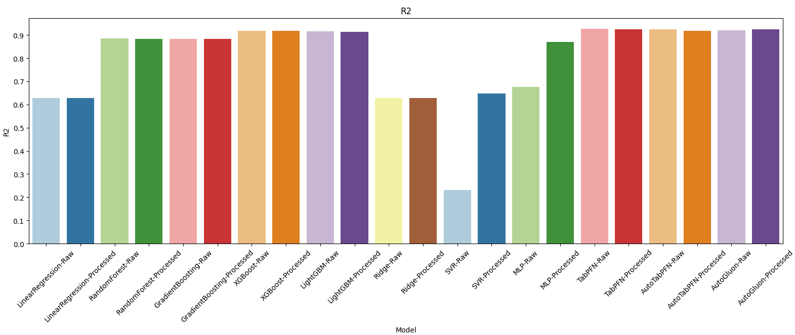
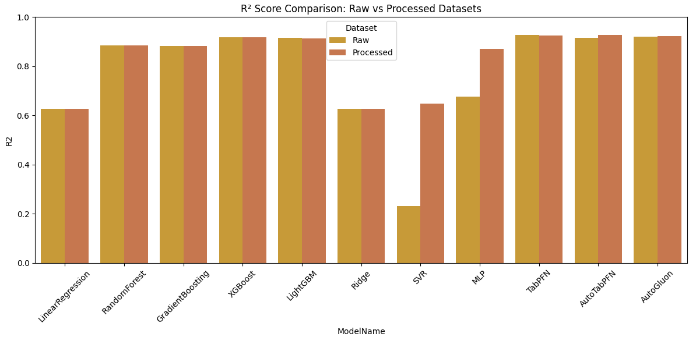
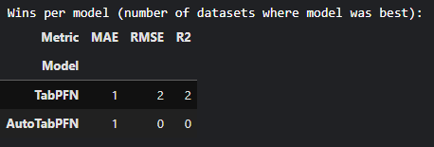
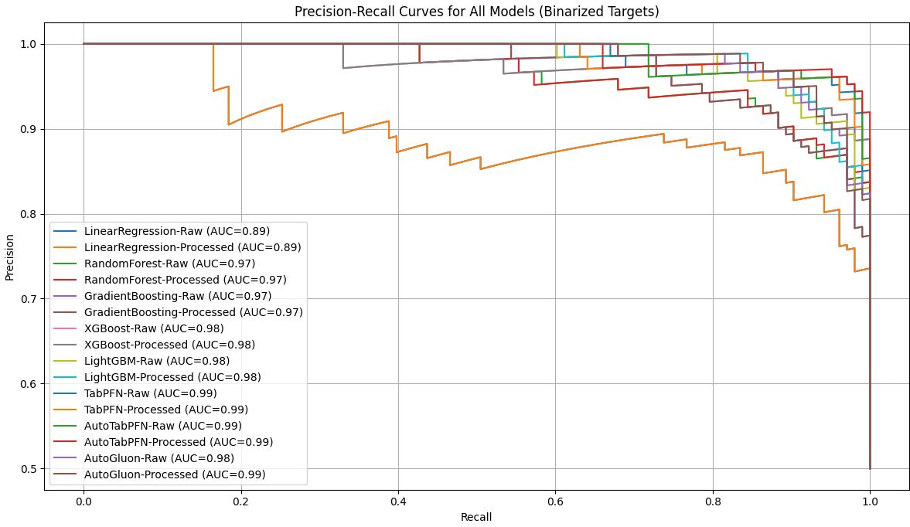

Cpu activity:
Model | MAE | RMSE | R2
0 | LinearRegression-Raw | 1.508049 | 2.034864 | 0.955312
1 | LinearRegression-Processed | 1.508221 | 2.041062 | 0.955039
2 | RandomForest-Raw | 0.782412 | 1.274798 | 0.982461
3 | RandomForest-Processed | 0.784090 | 1.283947 | 0.982208
4 | GradientBoosting-Raw | 0.853298 | 1.267151 | 0.982671
5 | GradientBoosting-Processed | 0.855982 | 1.271497 | 0.982552
6 | XGBoost-Raw | 0.650690 | 1.038671 | 0.988357
7 | XGBoost-Processed | 0.650690 | 1.038671 | 0.988357
8 | LightGBM-Raw | 0.842792 | 1.272377 | 0.982528
9 | LightGBM-Processed | 0.885608 | 1.352199 | 0.980267
10 | Ridge-Raw | 1.490288 | 2.034649 | 0.955321
11 | Ridge-Processed | 1.493255 | 2.032757 | 0.955404
12 | SVR-Raw | 3.912903 | 5.284289 | 0.698634
13 | SVR-Processed | 1.654421 | 2.583850 | 0.927946
14 | MLP-Raw | 1.830441 | 2.157111 | 0.949781
15 | MLP-Processed | 1.265165 | 1.815602 | 0.964424
16 | TabPFN-Raw | 0.563935 | 0.933783 | 0.990590
17 | TabPFN-Processed | 0.574850 | 0.946012 | 0.990341
18 | AutoTabPFN-Raw | 0.519147 | 0.847907 | 0.992241
19 | AutoTabPFN-Processed | 0.449105 | 0.739847 | 0.994092
20 | AutoGluon-Raw | 0.473352 | 0.655403 | 0.995364
21 | AutoGluon-Processed | 0.472272 | 0.652653 | 0.995403

Normalized:
Model | MAE | RMSE | R2
0 | LinearRegression-Raw | 1.381172 | 1.295375 | 0.959724
1 | LinearRegression-Processed | 1.381329 | 1.299321 | 0.959450
2 | RandomForest-Raw | 0.716585 | 0.811525 | 0.986998
3 | RandomForest-Processed | 0.718121 | 0.817349 | 0.986745
4 | GradientBoosting-Raw | 0.781507 | 0.806656 | 0.987209
5 | GradientBoosting-Processed | 0.783966 | 0.809423 | 0.987090
6 | XGBoost-Raw | 0.595945 | 0.661208 | 0.992921
7 | XGBoost-Processed | 0.595945 | 0.661208 | 0.992921
8 | LightGBM-Raw | 0.771885 | 0.809983 | 0.987065
9 | LightGBM-Processed | 0.811099 | 0.860797 | 0.984794
10 | Ridge-Raw | 1.364905 | 1.295239 | 0.959733
11 | Ridge-Processed | 1.367623 | 1.294034 | 0.959817
12 | SVR-Raw | 3.583697 | 3.363929 | 0.701861
13 | SVR-Processed | 1.515229 | 1.644855 | 0.932232
14 | MLP-Raw | 1.676440 | 1.373197 | 0.954168
15 | MLP-Processed | 1.158723 | 1.155795 | 0.968878
16 | TabPFN-Raw | 0.516489 | 0.594437 | 0.995164
17 | TabPFN-Processed | 0.526486 | 0.602223 | 0.994915
18 | AutoTabPFN-Raw | 0.475470 | 0.539770 | 0.996823
19 | AutoTabPFN-Processed | 0.411320 | 0.470980 | 0.998684
20 | AutoGluon-Raw | 0.433527 | 0.417223 | 0.999961
21 | AutoGluon-Processed | 0.432538 | 0.415473 | 1.000000

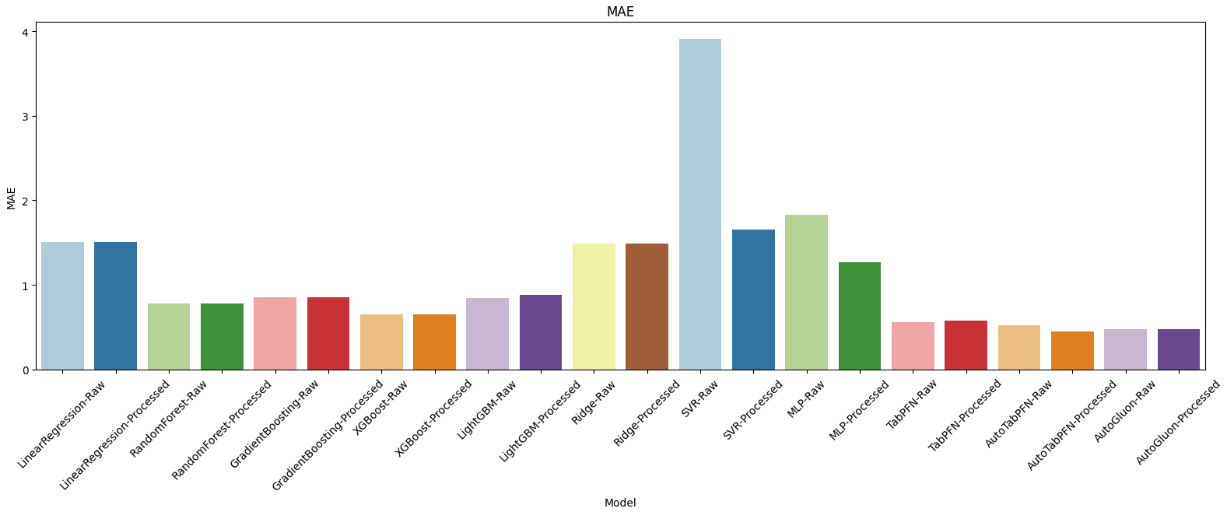
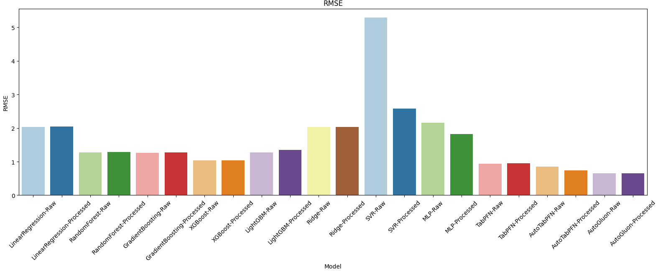
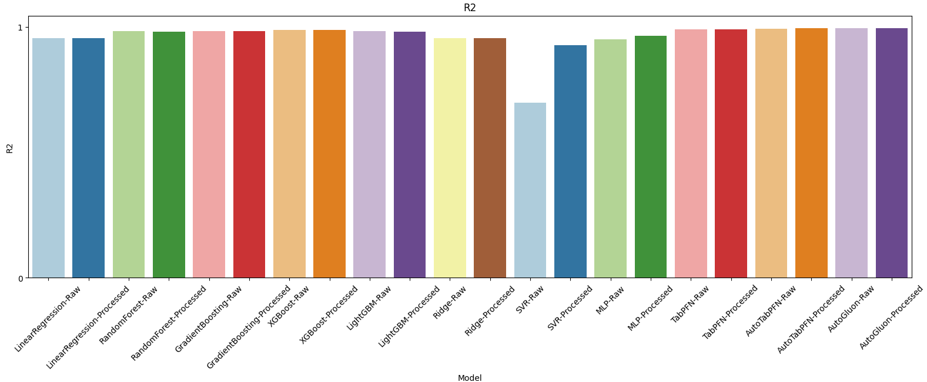
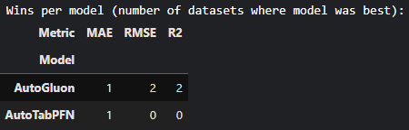
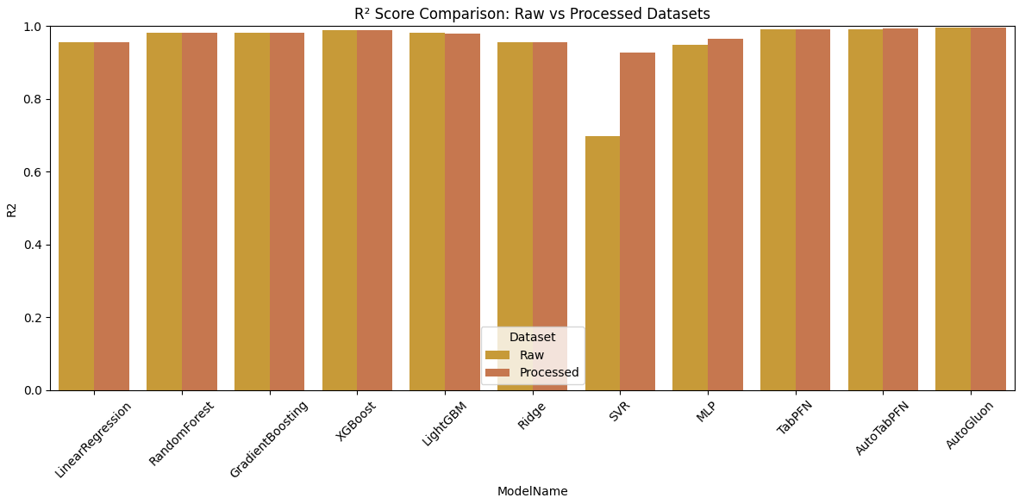
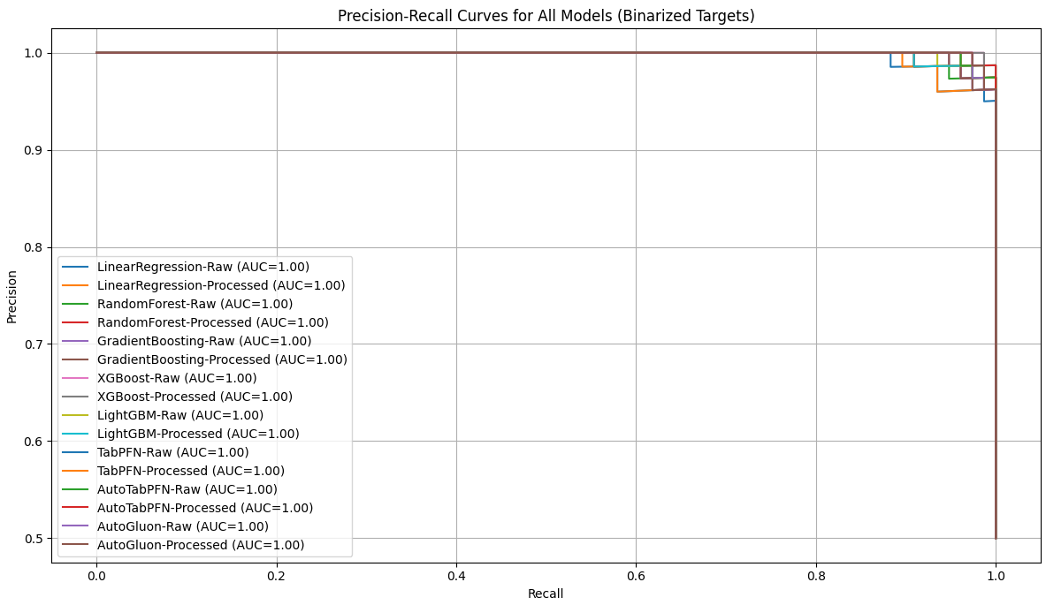

housing-prices-dataset:
Model | MAE | RMSE | R2 | FitTime
0 | LinearRegression-Raw | 9.796797e+05 | 1.331071e+06 | 0.649475 | 0.004453
1 | LinearRegression-Processed | 9.796797e+05 | 1.331071e+06 | 0.649475 | 0.002010
2 | RandomForest-Raw | 1.025290e+06 | 1.401263e+06 | 0.611532 | 0.179859
3 | RandomForest-Processed | 1.024279e+06 | 1.403586e+06 | 0.610243 | 0.174963
4 | GradientBoosting-Raw | 9.640589e+05 | 1.301872e+06 | 0.664686 | 0.073766
5 | GradientBoosting-Processed | 9.640589e+05 | 1.301872e+06 | 0.664686 | 0.074068
6 | XGBoost-Raw | 1.062316e+06 | 1.425624e+06 | 0.597908 | 0.069326
7 | XGBoost-Processed | 1.062316e+06 | 1.425624e+06 | 0.597908 | 0.046648
8 | LightGBM-Raw | 1.024870e+06 | 1.390040e+06 | 0.617730 | 0.061564
9 | LightGBM-Processed | 1.024309e+06 | 1.381195e+06 | 0.622579 | 0.030820
10 | Ridge-Raw | 9.801056e+05 | 1.332001e+06 | 0.648986 | 0.005527
11 | Ridge-Processed | 9.795083e+05 | 1.331263e+06 | 0.649374 | 0.001528
12 | SVR-Raw | 1.763890e+06 | 2.359647e+06 | -0.101564 | 0.010718
13 | SVR-Processed | 1.763889e+06 | 2.359648e+06 | -0.101565 | 0.009305
14 | MLP-Raw | 1.939397e+06 | 2.484423e+06 | -0.221144 | 1.597068
15 | MLP-Processed | 5.003527e+06 | 5.483922e+06 | -4.949745 | 1.854935
16 | TabPFN-Raw | 9.184521e+05 | 1.276155e+06 | 0.677802 | 0.345370
17 | TabPFN-Processed | 9.303523e+05 | 1.288817e+06 | 0.671377 | 0.293411
18 | AutoTabPFN-Raw | 9.804764e+05 | 1.358816e+06 | 0.634710 | 450.037626
19 | AutoTabPFN-Processed | 9.528809e+05 | 1.319788e+06 | 0.655393 | 412.566105
20 | AutoGluon-Raw | 9.882014e+05 | 1.355446e+06 | 0.636520 | 10.763353
21 | AutoGluon-Processed | 1.015050e+06 | 1.379927e+06 | 0.623272 | 9.241713

Normalized:
Model | MAE | RMSE | R2 | FitTime
0 | LinearRegression-Raw | 0.760874 | 0.790955 | 0.958208 | 0.004453
1 | LinearRegression-Processed | 0.760874 | 0.790955 | 0.958208 | 0.002010
2 | RandomForest-Raw | 0.796297 | 0.832664 | 0.902228 | 0.179859
3 | RandomForest-Processed | 0.795512 | 0.834044 | 0.900326 | 0.174963
4 | GradientBoosting-Raw | 0.748742 | 0.773604 | 0.980648 | 0.073766
5 | GradientBoosting-Processed | 0.748742 | 0.773604 | 0.980648 | 0.074068
6 | XGBoost-Raw | 0.825054 | 0.847140 | 0.882127 | 0.069326
7 | XGBoost-Processed | 0.825054 | 0.847140 | 0.882127 | 0.046648
8 | LightGBM-Raw | 0.795971 | 0.825995 | 0.911371 | 0.061564
9 | LightGBM-Processed | 0.795535 | 0.820739 | 0.918526 | 0.030820
10 | Ridge-Raw | 0.761204 | 0.791507 | 0.957485 | 0.005527
11 | Ridge-Processed | 0.760741 | 0.791069 | 0.958059 | 0.001528
12 | SVR-Raw | 1.369935 | 1.402159 | -0.149843 | 0.010718
13 | SVR-Processed | 1.369934 | 1.402159 | -0.149845 | 0.009305
14 | MLP-Raw | 1.506244 | 1.476304 | -0.326266 | 1.597068
15 | MLP-Processed | 3.886016 | 3.258678 | -7.302637 | 1.854935
16 | TabPFN-Raw | 0.713321 | 0.758322 | 1.000000 | 0.345370
17 | TabPFN-Processed | 0.722563 | 0.765846 | 0.990520 | 0.293411
18 | AutoTabPFN-Raw | 0.761492 | 0.807441 | 0.936424 | 450.037626
19 | AutoTabPFN-Processed | 0.740060 | 0.784250 | 0.966938 | 412.566105
20 | AutoGluon-Raw | 0.767492 | 0.805439 | 0.939094 | 10.763353
21 | AutoGluon-Processed | 0.788344 | 0.819986 | 0.919548 | 9.241713
